**Task 01**

**To Create the EC2 instance and launch using Linux OS**

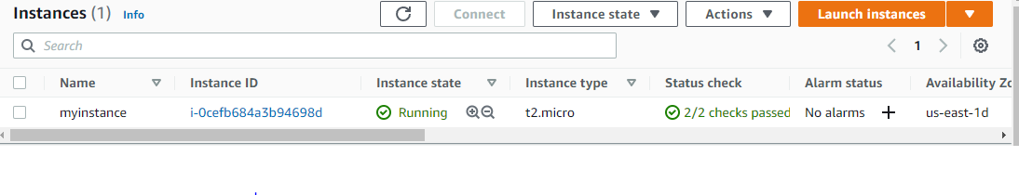

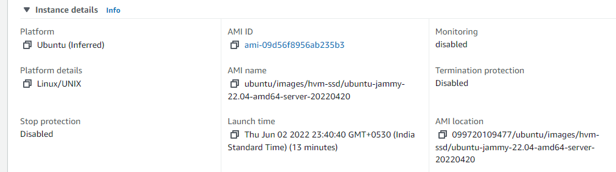

**Task 02**

**To Display the S3 bucket details using lambda function**

**S3 Bucket**

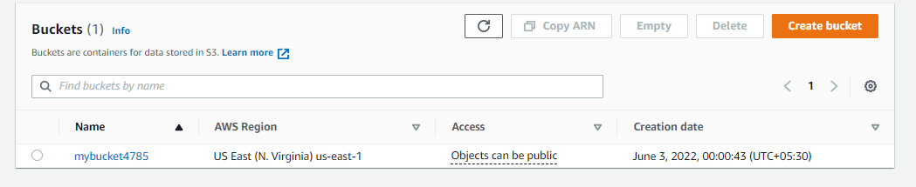

**Lambda function**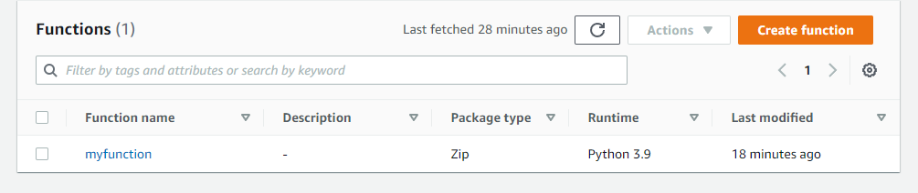

**Lambda function and Execution**

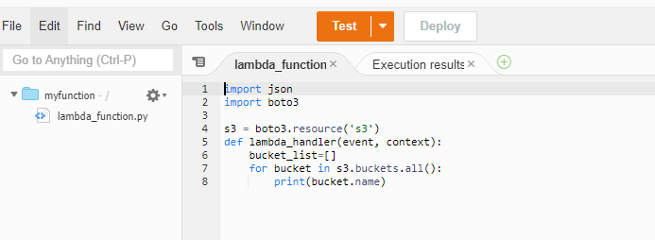

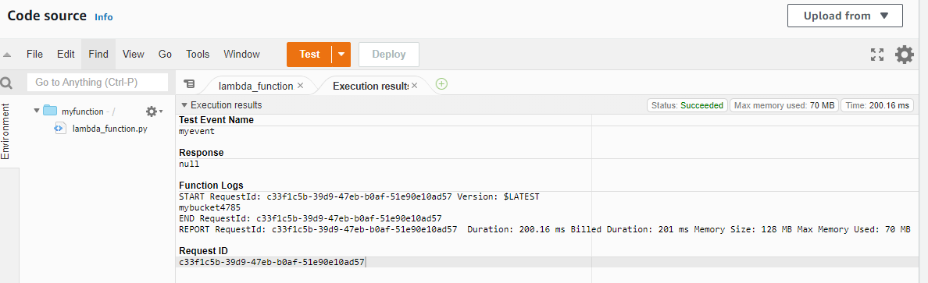

**Task 03**

**To Read the Dynamo DB data from Lambda function**

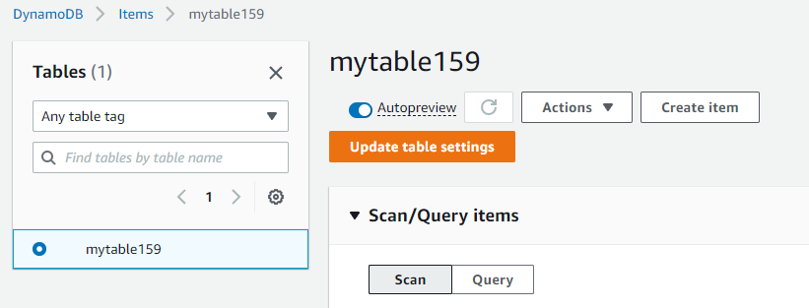

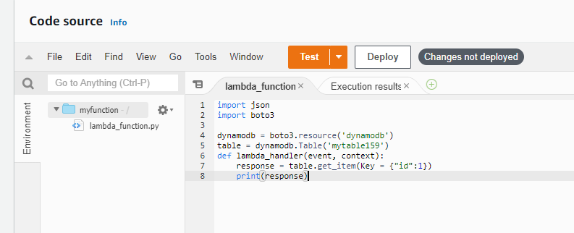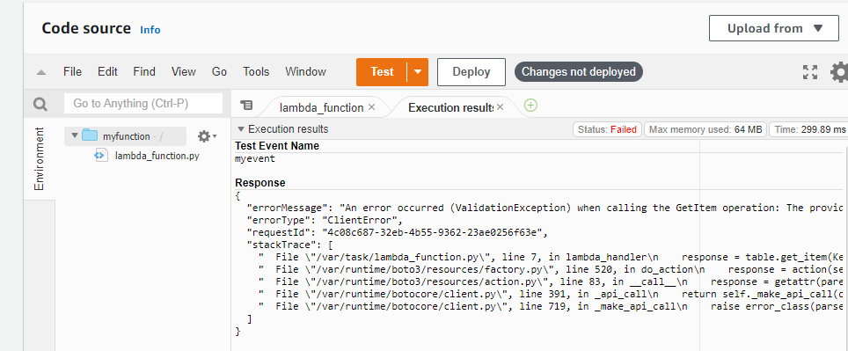

**Task 04**

**To Use Cloudwatch analyse the metrics of S3 objects**

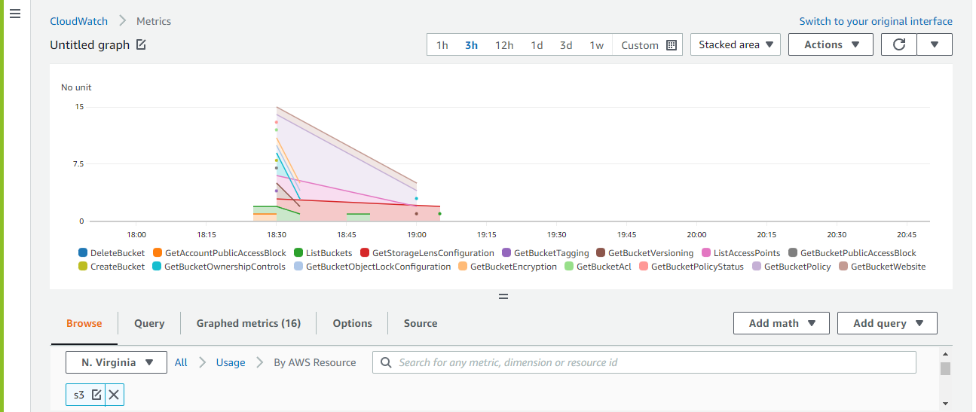

**Task 09**

**To Set up the MongoDB and create the capped collection not beyond the 500 mb data**

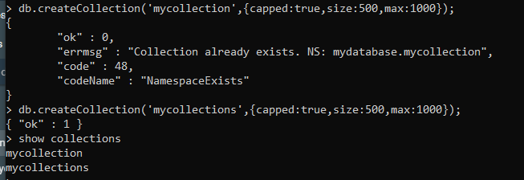

**Task 10**

**To Create the CRUD operation for Employee datamodel in MongoDB**

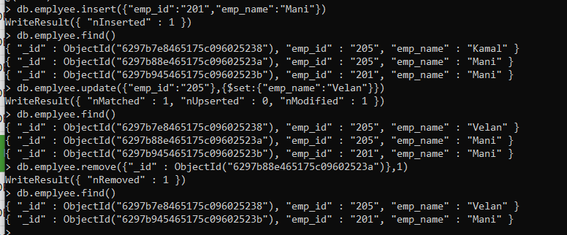

**Task 11**

**To Create the view for Employee table which will hide the sensitive data**

CREATE VIEW Place_is_in_Madurai AS SELECT DOB, emp_name FROM employee WHERE place = 'Madurai';

select * from Place_is_in_Madurai;

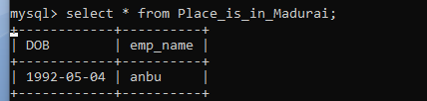

**Task 12**

**Creating Table**

create table employee (emp_id int primary key, emp_name varchar(30) not null, DOB date not null,

place varchar(30));

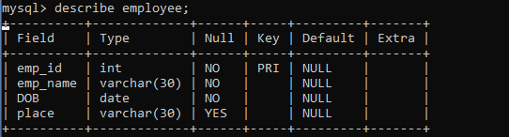

**Inserting Table**

insert into employee (emp_id, emp_name, DOB , place) values ('1', 'anbu', '1992-04-04', 'Madurai');

insert into employee (emp_id, emp_name, DOB , place) values ('2', 'vel', '1993-05-14', 'Chennai');

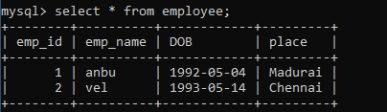

**View Table**

select * from employee;



**Update Table**

update employee set DOB = '1992-05-06' where emp_id = '1';

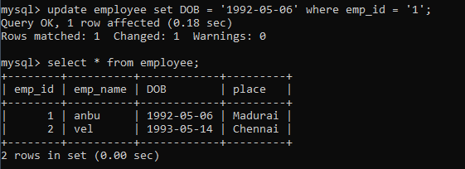

**Delete Table**

delete from employee where emp_name = 'vel';

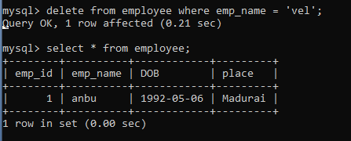

**Task 13**

**To Using Python , create , insert and delete the record in Mysql DB**

**import mysql.connector**

conn = mysql.connector.connect(user='root', password='Ram@93', host='localhost', database='task')

a = conn.cursor()

task = """create table employee (emp_id int primary key, emp_name varchar(30) not null, DOB date not null,

place varchar(30))"""

a.execute(task)

task_insert = """insert into employee (emp_id, emp_name, DOB , place) values ('1', 'anbu', '1992-04-04', 'Madurai'),

('2', 'vel', '1993-05-14', 'Chennai')"""

a.execute(task_insert)

conn.commit()

task_delete = """delete from employee where emp_name = 'vel'"""

a.execute(task_delete)

conn.commit()